**بسم الله الرحمن الرحيم**



**Faculty of Engineering**

**Computer Engineering Department**

**Software Engineering**

**Software document for:**

**Publishing House software project**

مهند عقبة طه 21620447

هيثم محمد عجاج 21410520

**Table of Contents**

**Preface …………………………………………………………………….. 4 Glossary …………………………………………………………………….5**

**Chapter 1: Introduction …………………………………………….6**

**Chapter 2: Process Model …………………………………………. 7**

**Chapter 3: Requirements …………………………………………8**

**3.1 Functional Requirements ………………………….. 8**

**3.2 non-Functional Requirements …………………… 9**

**Chapter 4: System Architecture** ……………………………... 10

**4.1 Architecture ……………………………………………… 10**

**4.2 Layers ……………………………………………………….. 11**

**Chapter 5: System Models (UML) …………………………… 12**

**5.1 Use Case Diagram ……………………………………… 12-13**

**5.2 Sequence Diagram …………………………………… 14-18**

**5.3 Class Diagram …………………………………………… 19**

**5.4 Normalization…………………………………………….20**

**5.5 ERD and relational model…………………………..21-22**

**Chapter 6: System Testing ……………………………………….. 23**

**Chapter7: System Evolution ………….………………………….. 24**

**Chapter 8: Time Sheet and cost ………………………………..25**

**8.1 Task………………………………………………………………… 26**

**8.2 Costs ……………………………………………………………… 26**

**Chapter 9: Appendices …………………………………………….. 27**

**9.1 layered architecture ……………………………………… 27**

**9.2 Database………………. ……………………………………...28-29**

**9.3 Views …………………………………………………………….. 30-35**

**Table of figures**

**Figure 4.1: System architecture……….... ……………. 10**

**Figure 4.2: System Layers ……………………………11**

**Figure 5.1: Use Case model …………………………….13**

**Figure 5.2.1: Login sequence diagram ………………….14**

**Figure 5.2.2: Admin sequence diagram ………………...15**

**Figure 5.2.3: publish book sequence diagram ………….16**

**Figure 5.2.4: Buy book sequence diagram ……………..16**

**Figure 5.2.5: Design book sequence diagram ………….17**

**Figure 5.3: Class diagram ………………………………19**

**Figure 5.5.1: ER diagram ………………………………21**

**Figure 5.3: Relational model……………………………22**

**Figure 9.3.1: Login interface ……………………………30**

**Figure 9.3.2: Create user interface ……………………..31**

**Figure 9.3.3: Admin Login interface ……………………31**

**Figure 9.3.4: Main menu interface ……………………..32**

**Figure 9.3.5: publish book interface ……………………32**

**Figure 9.3.6: Buy book interface ………………………..33**

**Figure 9.3.7: Design interface …………………………..33**

**Figure 9.3.8: Add Bookstore interface …………............34**

**Figure 9.3.9: display requests interface ………………...34**

**Table of tables**

**Table 8.1: Time sheet ……………………………………22**

**Preface:**

This requirement specification document was written to describe the requirement of the publishing house software project because of its importance in system validation and maintenance, and it makes a basis for the bid customer and developer in business systems.

This document is prepared for educational purposes to be read by the course instructor and other student may read it to advantage of how the structure of the requirement document should be.

This is the first version of the document, it may be changed later if we find that new functions have to be included in the project, or we may change it if the instructor fined that the document should be better.

**Glossary:**

|  |  |
| --- | --- |
| **Term** | **Definition** |
| GUI | Graphical User Interface (Design of the program) |
| Software Requirements Specification | A document that completely describes all of the functions of a proposed system and the constraints under which it must operate. For example, this document. |
| Stakeholder | Authors, buyers and the system administrator. |
| Use- Case | A list of steps, typically defining interactions between a role and a system, to achieve a goal. |
| User | Any Person (Managers, Employees) using the software to access system information. |
| Actor | A person, a system or a technical device in the context of a system that interacts with the system. |
| Attribute | A characteristic property of an entity. |
| Class | Represents a set of objects of the same kind, by describing the structure of the object, the way they can be manipulated and how they behave and consist of attributes and methods. |
| UML | Unified Modifying Language, used for modelling the system. |

**Chapter 1: introduction**

The publishing house is the institution that prints books after they reach an agreement between them and the authors. These books are distributed to many points of sale inside the country or in points outside

This software will help the owner of the publishing house all the data that need to keep track such as authors, books, bookshops, it main functions concentrating on storing and retrieving data, and doing some simple calculations like book prices.

This software will help the authors to decide the design of their books through choosing from simple editing options, and help the customers and normal readers to choose their favorite books without going to choose it manually form the shelves.

This project will be implemented using java language and store data in file system.

**Chapter 2: Process model**

We have used the agile method in developing this software, by using this method we were be able to build the system in iterative manner, in other words, we build a part of the system then discuss and review this part if it satisfy the needed requirement and check if we want it to include other feature or services, if yes, we will repeat this step else, we go forward to build the next part.

For example, after accomplishing first few classes of the system we decided to make the admin to be able to sign in to the system without the need to make account and having the ability to add different book stores.

We see that this method is better than the waterfall model which needs to know every detail of the system and having full plan before start developing which we can’t do because we are students and learning gradually.

**Chapter 3: Requirements**

**3.1 Functional Requirement:**

* The user should be able to see existed all of books in this publishing house.
* The administrator must be able to see the profits from the set of books that have been sold.
* The administrator should be able to add/delete bookstores.
* The administrator should be able to see the orders of the customers including requests and designs.
* System users should enter the system in secured manner.
* The authors should be able to choose the book style.
* The system must contain several options through which to separate books to be sold, books that are borrowed, and books that have been published that belong to this publishing house

**3.2 Non-Functional Requirement:**

* Performance requirements:
* The system must respond the business operation in less than 3 seconds for user.
* As a system, user requests/issues should be supported and addressed.
* Usability
* The system has user-friendly interface.
* Availability
* The system must be available 24 hours daily in week
* Downtime within normal working hours shall not exceed five seconds in any one day.)In the case of maintenance only ten minutes a day (.

**Chapter 4: System Architecture and layers**

**4.1 System Architecture:**

In early stage of the software development we have to design the system architecture to define the major components of the system and the communication between these components, the following diagram show our system components as a block linked together:

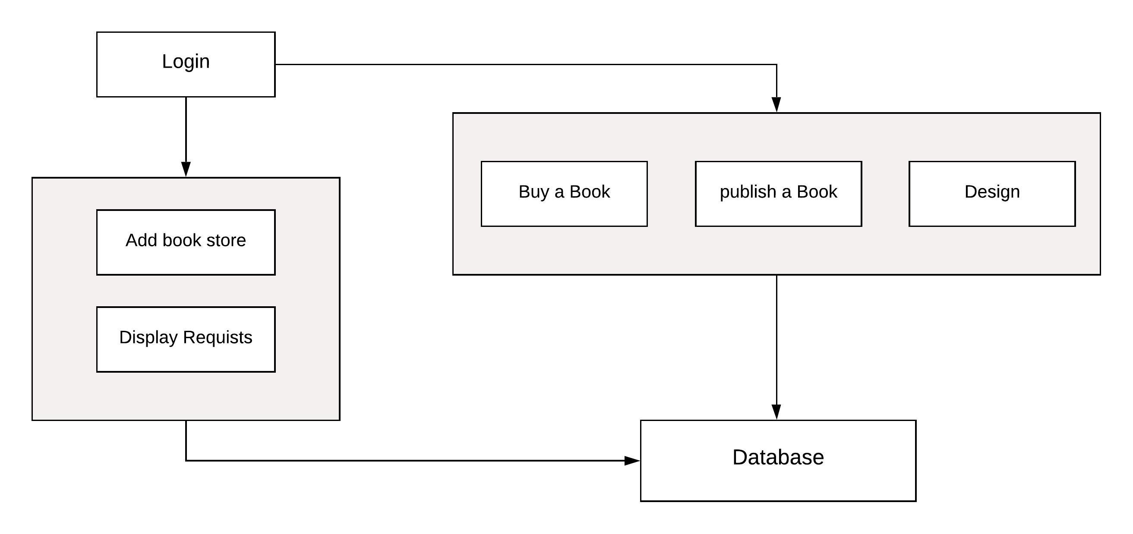

**Figure 4.1: System architecture**

Our system consist of several interfaces an component which is login interface and different services according to the user of the system, for example, the administrator can add bookstores while the authors cannot, but the author can choose the book options and styles, however in both cases the order information will be stored in database.

**4.2 System layers:**

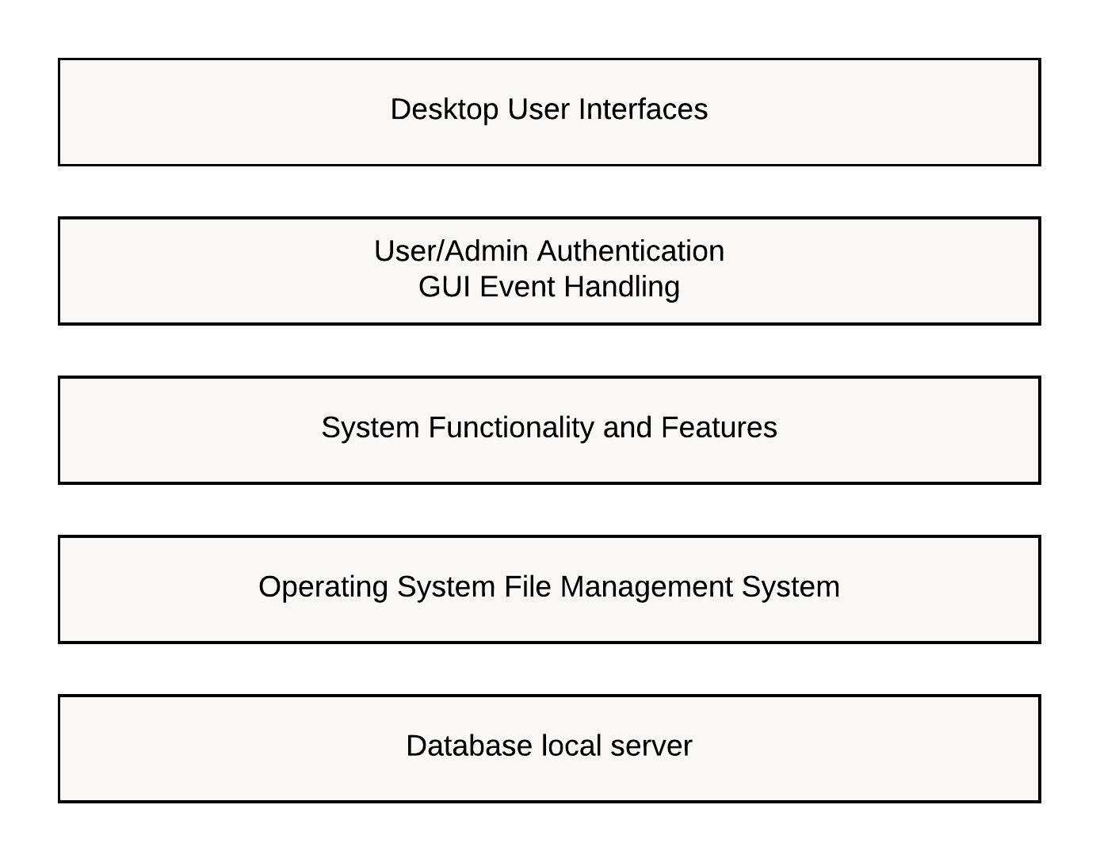

**Figure 4.2: System Layers**

This is a layered architecture organizes the system as a set of layers, each has a different services, in this figure we see that the first layer is the user GUI interface which the user see first when opening the application, then before entering the system the user must pass through the authentication layer through checking the username and password, then go to the system services and features layer, if the user need to store information in database then the OS layer will manage this process to store the data in local server as a data in physical memory layer.

**Chapter 5: System models**

**5.1 Use case diagram:**

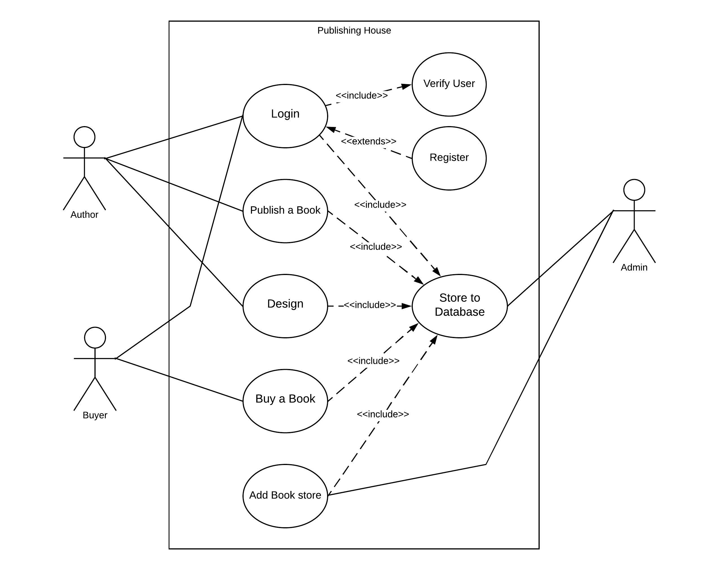

**Figure 5.1: Use Case model**

This use case model represents several tasks of the system and the actors who interested with each task, for example the author have to login which involve the user verification or the registration if he hasn’t an account and he will take advantage of the publishing book features and design features, in the buyer or borrower will interact with “buy a book” interface and “Login” interface, on the other hand, the administrator will have the ability to “add book store” or see the requirements of the authors and buyers through accessing the database.

**5.2** **Sequence diagram:**

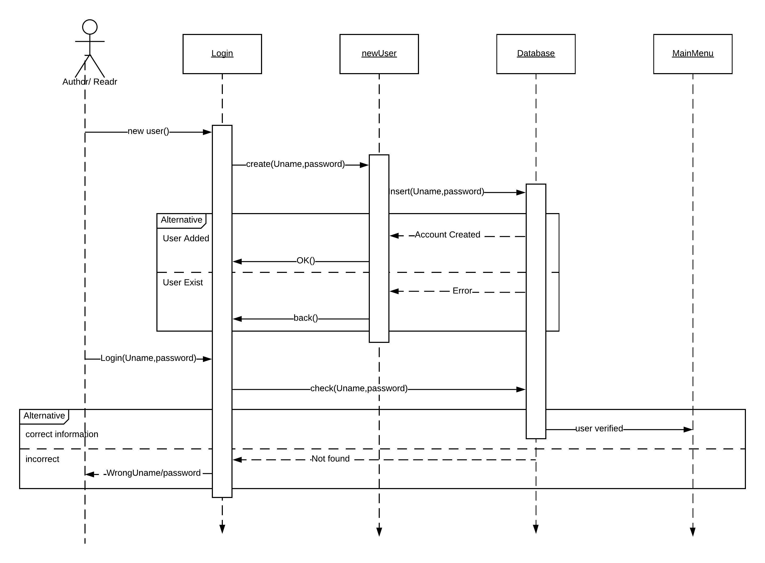

**Figure 5.2.1: Login sequence diagram**

This is the sequence diagram of the user login process, first of all, the user have to create account to be able to access the software, he will invoke the method (createUser()) by clicking (new user) button then it will create new object from the (newUser) class with a specific username and password and store it in a (app_user) table, if the account is exist then this will cause an error.

Then the user can login to system by typing his username and password

Then the system will go to (app_user) table and search for this username and password if it exist then let him to enter the main menu, else, the system will display an (wrong username or password) message.

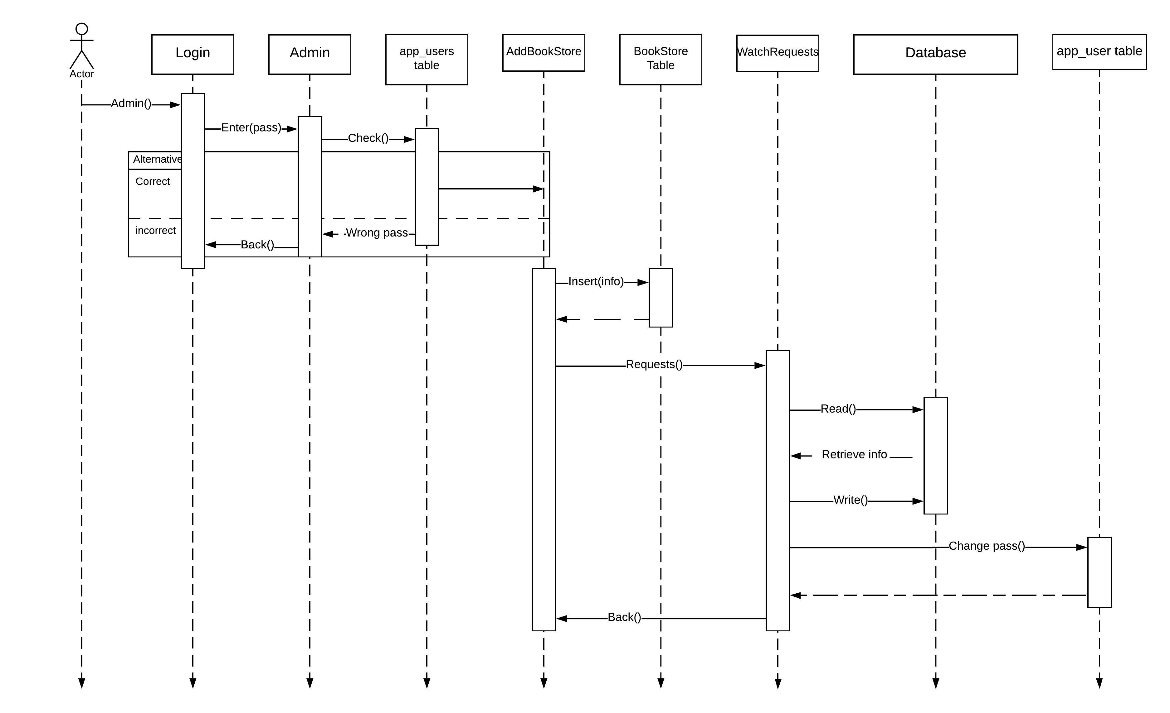

**Figure 5.2.2: Admin sequence diagram**

The previous figure is a sequence diagram represent the admin access to the system, the admin can access to the system through entering a predefined serial number which he have to write in the text field that appear when clicking on the (admin) button in the login interface after checking the (AdminPass) file, if the number is correct then the system will open the (AddBookStore) interface, the admin can define the information of the bookstore then store it on a Bookstores table by clicking on (send) button, the administrator can see the requests of the authors or readers by clicking on (requests) button, from the (watchRequests) interface he can change his serial number by typing it in the text field then click on (save) button.

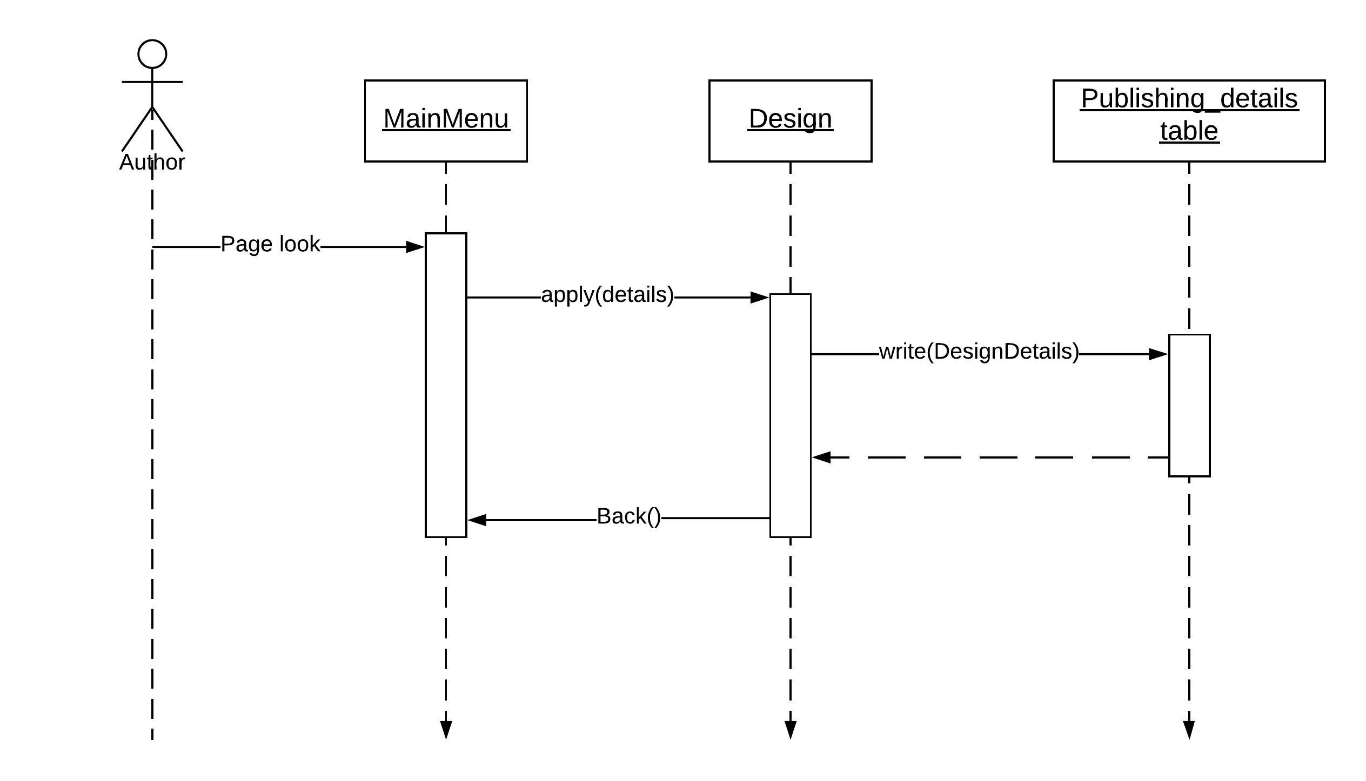

**Figure 5.2.3: publish book sequence diagram**

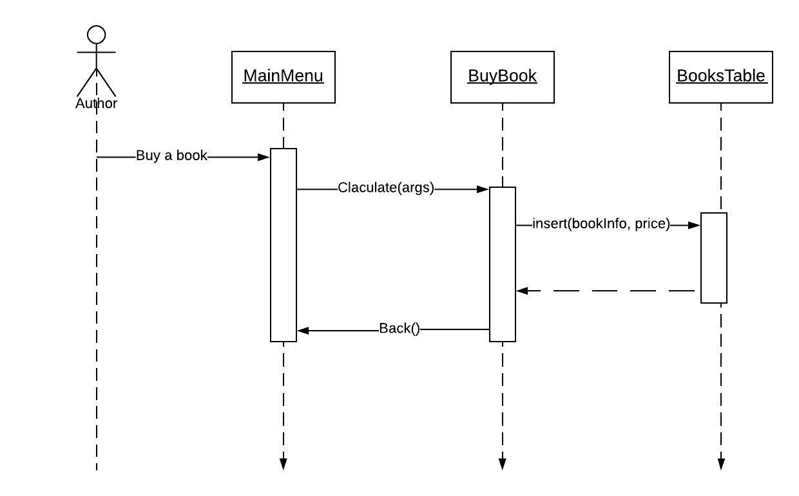

**Figure 5.2.4: Buy book sequence diagram**

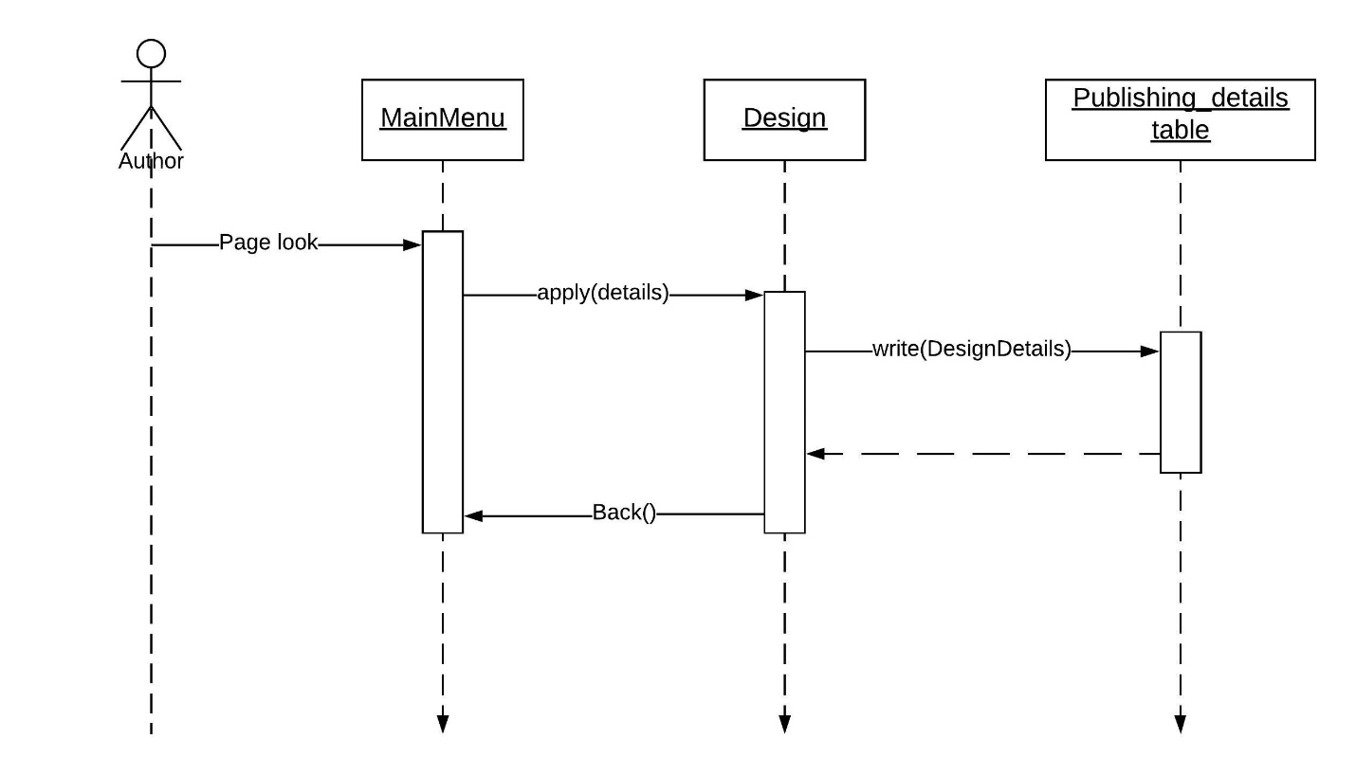

**Figure 5.2.5: Design book sequence diagram**

Each of the previous three figures represents a sequence diagram for publish a book, buy book, Design page use cases respectively, considering that the user has successfully logged the system in, in the main menu if he was an author he can choose the publish book option and different decisions such as number of books, quality of papers, number of bookstores that he want to distribute his book and through the equation:

Total= ((number_of_pages*0.005*nbooks)+(number_of_pages*paper_quality)+Bookstores)

The system will calculate the total price, then to save it to the database the user must click on (send) button.

In the sequence diagram of *Design* use case the author will determine the major characteristics of the page such the typeface and color of the page and the border and click (send) button to save in the database.

Also the buyer can choose one of several books which categorized in several categories then the system will calculate the total price considering the presence of taxes and save the information in (Buy) file.

**5.3** **Class diagram:**

**Figure 5.3: Class diagram**

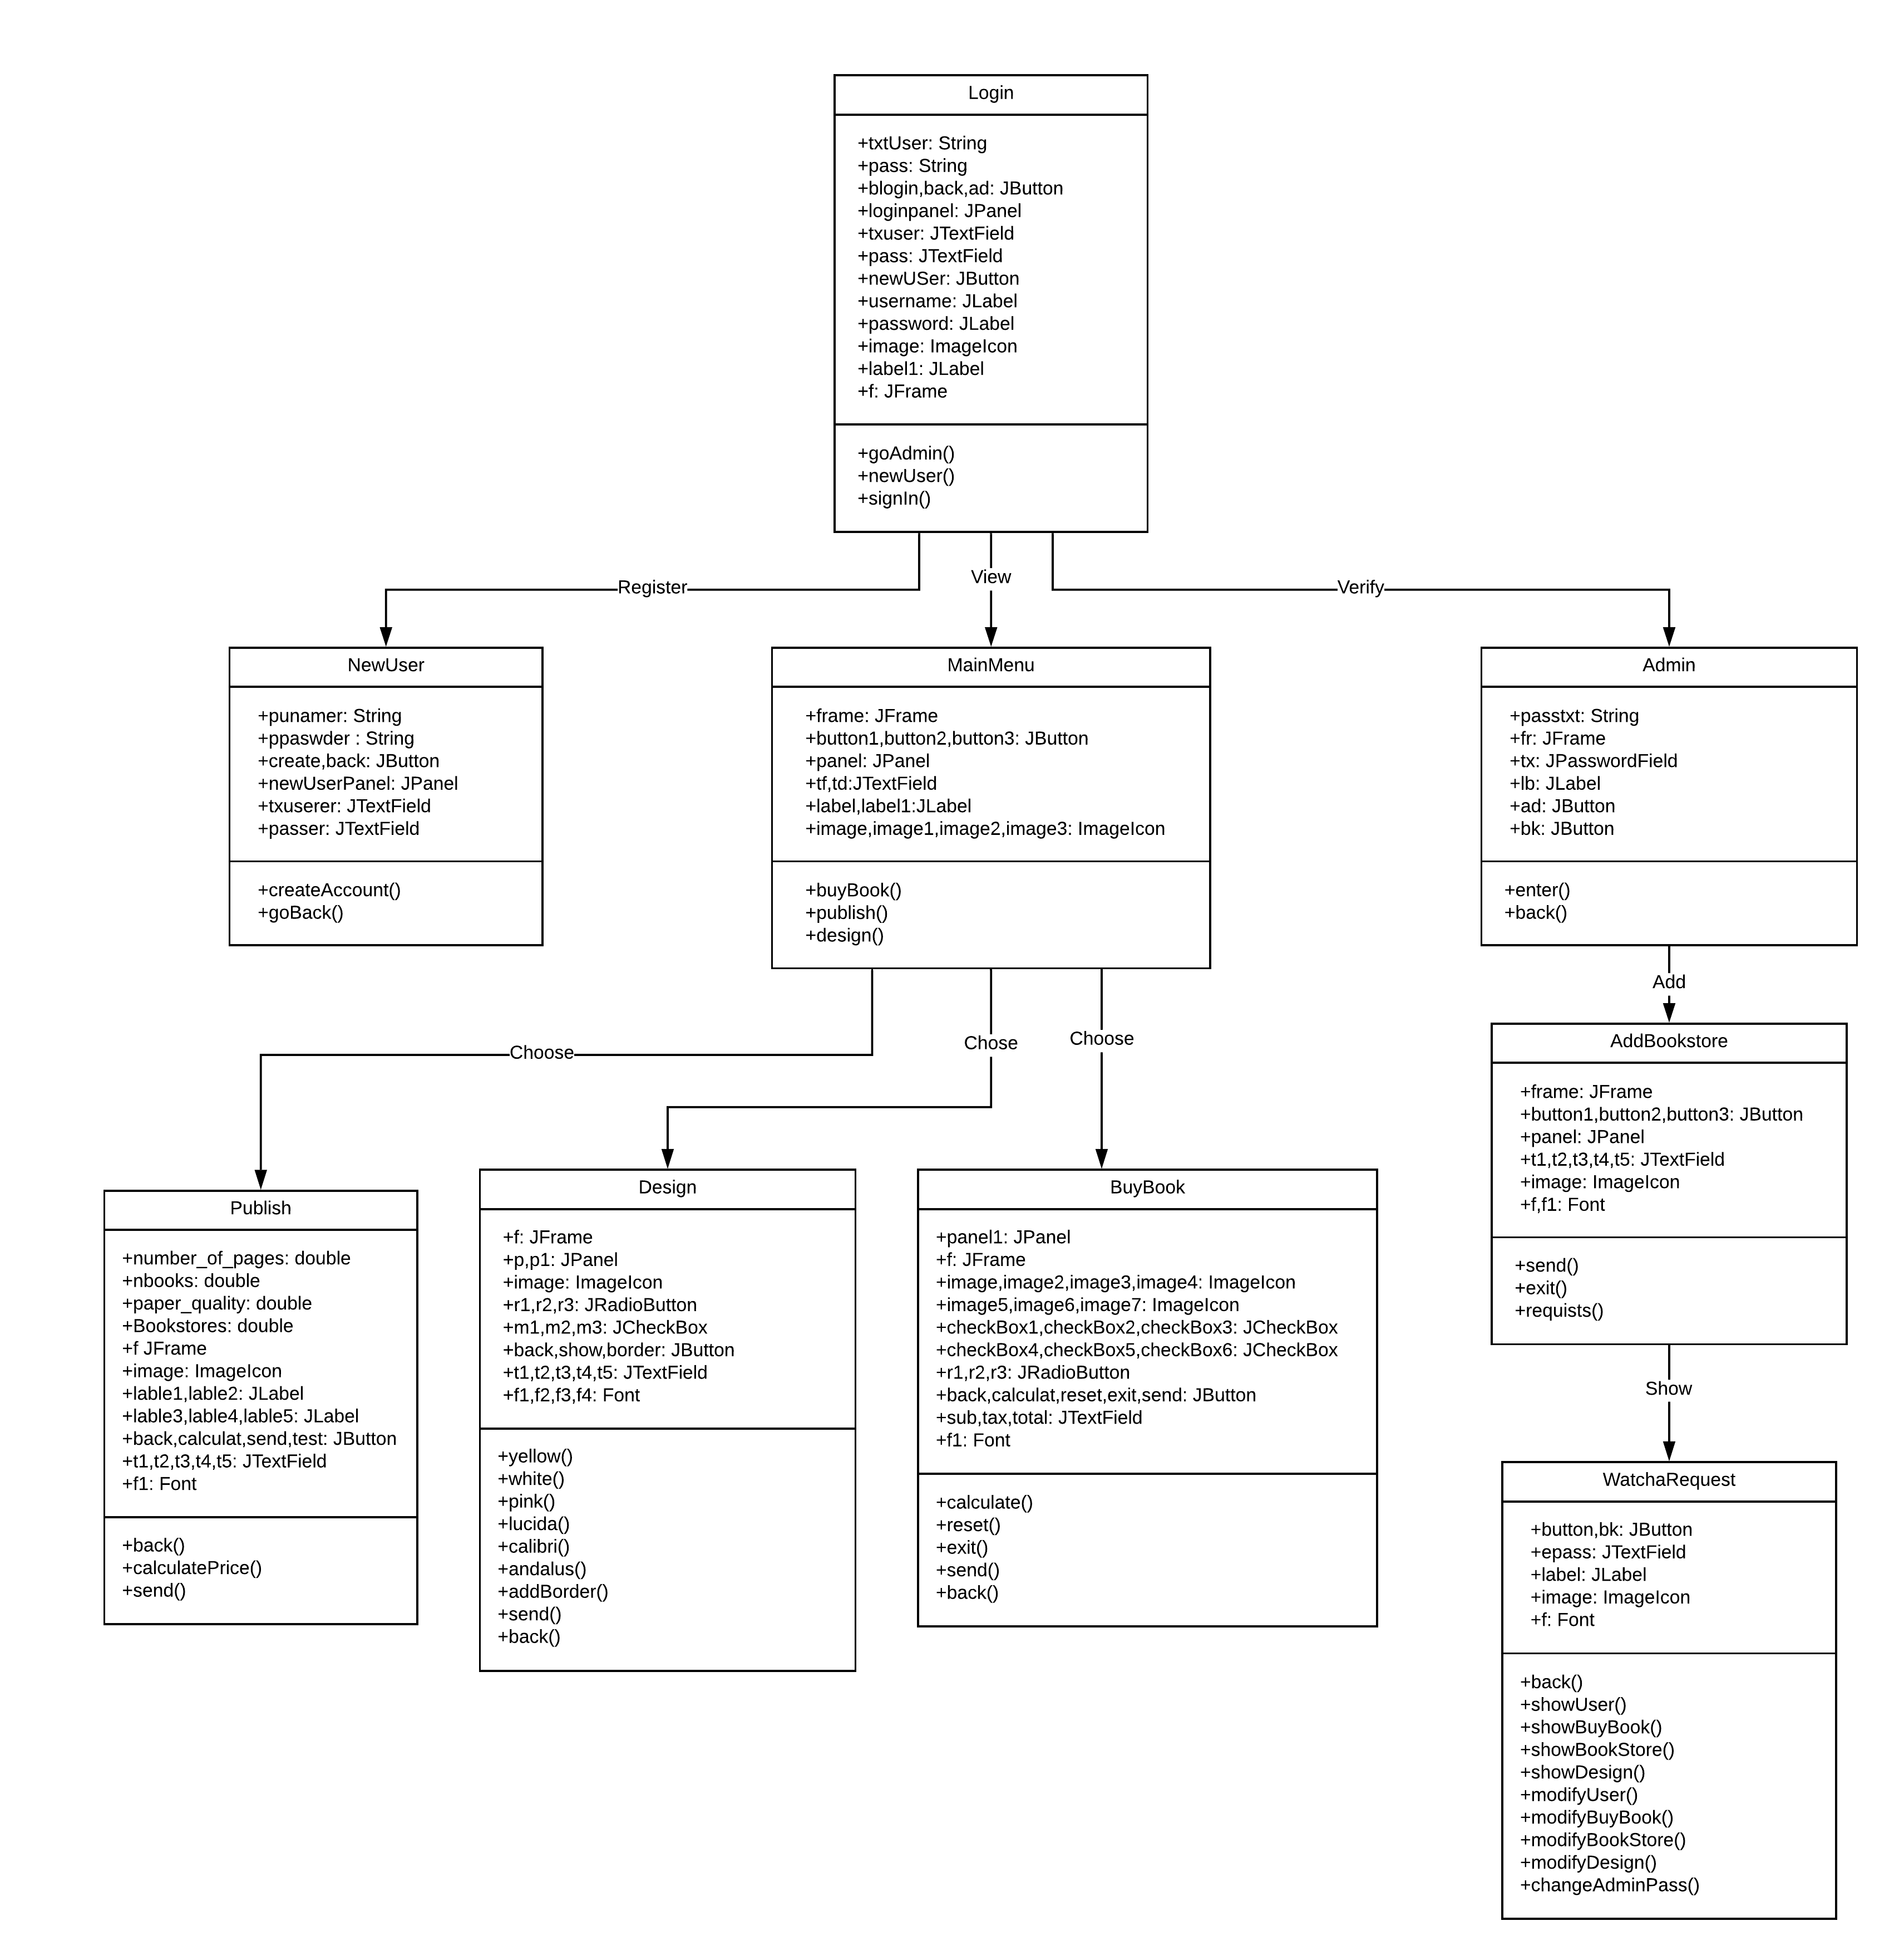

**5.4** **Normalization:**

**Unnormalized form:**



**First normal form:**

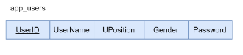

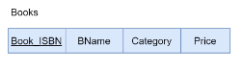

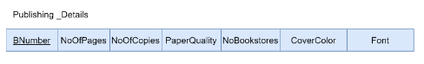

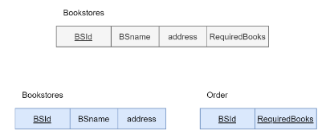

All previous “blue” tables is in 1NF because we have removed the repeating groups and in the last two table results from removing the multivalued attributes, the previous tables are also in the 2NF because there no partial dependencies and it in the 3NF because there is no transitive dependencies.

**5.5** **ERD and Relational model:**

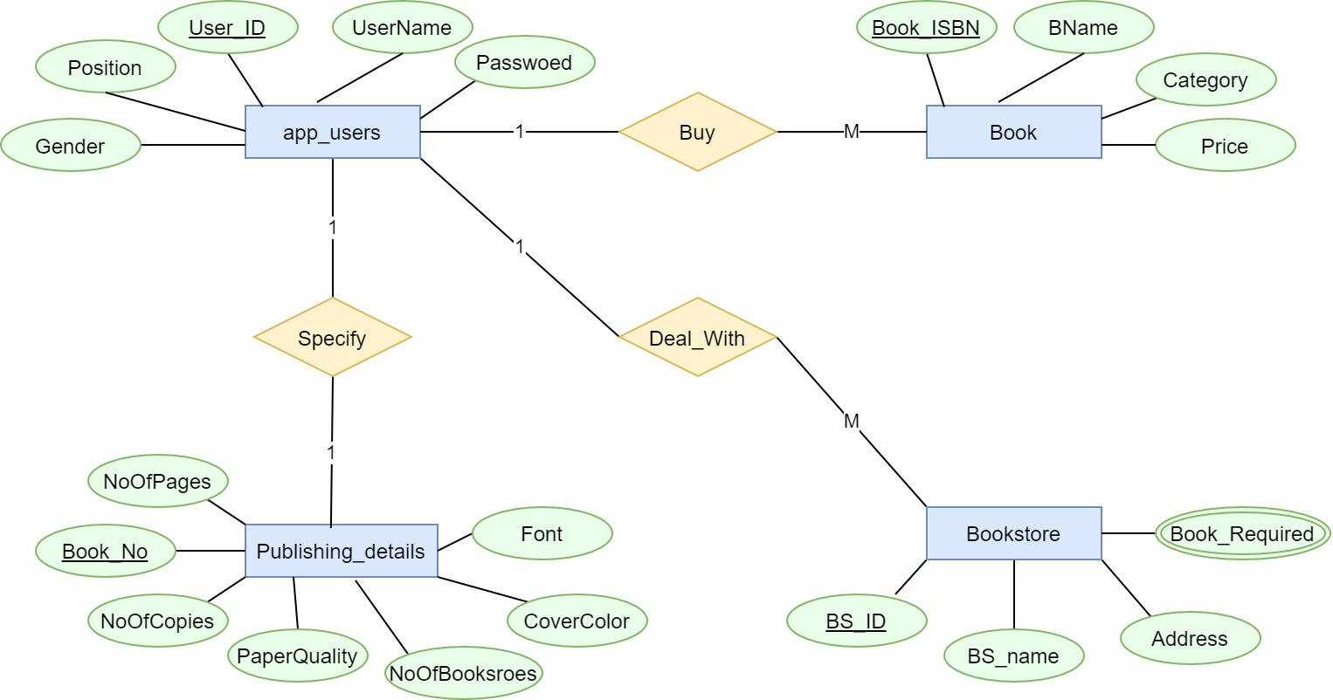

Figure 5.5.1: ERD

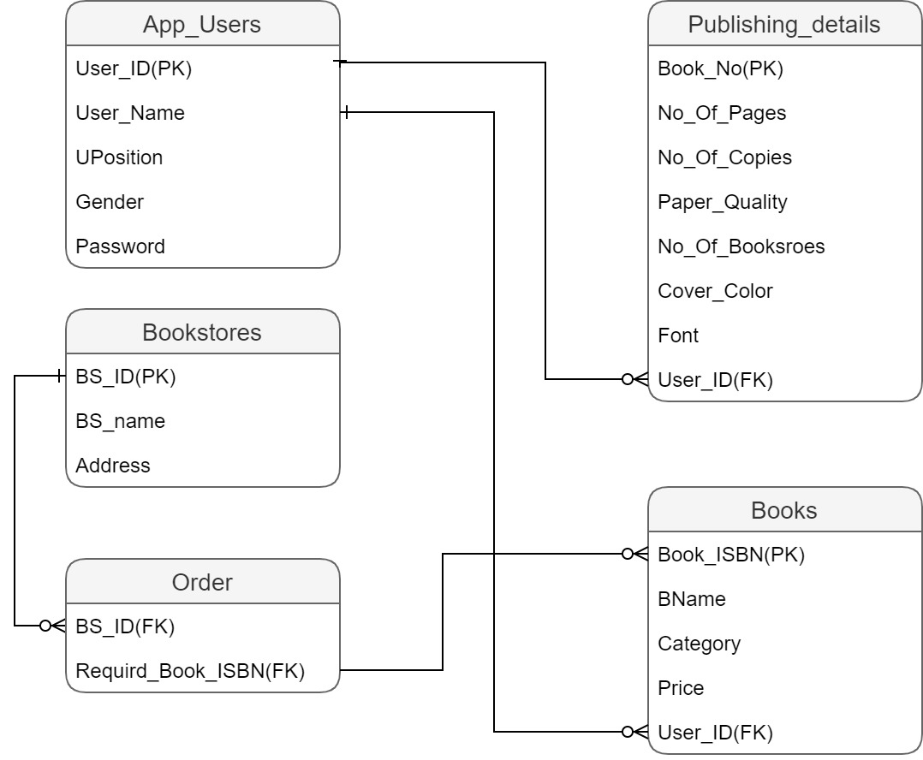

Figure 5.5.2: Relational model

**Chapter 6: System testing**

Unit testing: every line we wrote we checked it directly; the netbeans IDE helped us to do this testing by showing error messages when there is a syntax error.

Component Testing : after wrote a set of lines we checked it, for example when we wrote the code of writing data to files opened this file to make sure that the data were written successfully.

System Testing: we checked the program after we finished programming it we found that there is a problem when multiple users register to the system which causes the system to accept the latest user only.

Acceptance testing: this testing will be done by stakeholders.

**Chapter 7: System evolution**

* We got the requirements by doing discussion and brainstorming between the project partners.
* We began coding the software to satisfy the stated requirements.
* We have changed some parts of the system in response to changing the requirements.
* We have done our system incrementally by finishing the code block by block.
* We have tested the system and evaluated it to make sure that is meeting the predefined requirements.
* We have finished writing the documentation.

**Chapter 8 : Time sheet and cost**

**8.1 Time sheet:**

|  |  |  |  |  |  |  |
| --- | --- | --- | --- | --- | --- | --- |
| **Task** **Time** | **Requirements Elicitation** | | **Implementation** | **Architecture Design & Modeling** | **Testing and evaluation** | |
| **Week 1** |  |  |  |  |  | |
| **Week 2** |  | |  |  |  | |
| **Week 3** |  | |  |  |  | |
| **Week 4** |  | |  |  |  |  |

**Table 8.1: Time sheet**

Muhannad: Green

Haitham: Blue

Weak = 5 days

**8.2 Cost:**

Haitham:

Task1: 2 days * 4 hours per day * 10$ per hour = 80 $

Task3: 5 days * 4 hour per day *10$ per hour = 200$

Task4: 2 days * 4 hour per day *10$ per hour = 80$

Muhannad:

Task1: 3 days * 4 hours per day * 10$ per hour = 120 $

Task3: 5 days * 4 hour per day *10$ per hour = 200$

Task4: 3 days * 4 hour per day *10$ per hour = 120$

Total cost = 800$

**Chapter 9: Appendices**

**9.1 Layered architecture**

This layered approach supports the incremental development of systems. As a layer is developed, some of the services provided by that layer may be made available to users. The architecture is also changeable and portable. So long as its interface is unchanged, a layer can be replaced by another, equivalent layer. Furthermore, when layer interfaces change or new facilities are added to a layer, only the adjacent layer is affected. As layered systems localize machine dependencies in inner layers, this makes it easier to provide multi-platform implementations of an application system. Only the inner, machine-dependent layers need be re-implemented to take account of the facilities of a different operating system or database. The lowest

Layer includes system support software—typically database and operating system support. The next layer is the application layer that includes the components concerned with the application functionality and utility components that are used by other application components. The third layer is concerned with user interface management and providing user authentication and authorization, with the top layer providing user interface facilities. Of course, the number of layers is arbitrary.

**9.2 Database:**

A database is a collection of [information](https://searchsqlserver.techtarget.com/definition/information) that is organized so that it can be easily accessed, managed and updated. Computer databases typically contain aggregations of data records or [files](https://searchsqlserver.techtarget.com/definition/flat-file), containing information about sales transactions or interactions with specific customers.

In a [relational database](https://searchdatamanagement.techtarget.com/definition/RDBMS-relational-database-management-system), digital information about a specific customer is organized into rows, columns and tables which are indexed to make it easier to find relevant information through [SQL](https://searchsqlserver.techtarget.com/definition/SQL) or [NoSQL](https://searchdatamanagement.techtarget.com/definition/NoSQL-Not-Only-SQL) queries. In contrast, a [graph database](https://whatis.techtarget.com/definition/graph-database) uses nodes and edges to define relationships between data entries and queries require a special [semantic search](https://whatis.techtarget.com/definition/semantic-search) syntax.  As of this writing, [SPARQL](https://whatis.techtarget.com/definition/SPARQL) is the only semantic query language that is approved by the World Wide Web Consortium ([W3C](https://whatis.techtarget.com/definition/W3C-World-Wide-Web-Consortium)).

Typically, the database manager provides users with the ability to control read/write access, specify report generation and analyze usage. Some databases offer [ACID](https://searchsqlserver.techtarget.com/definition/ACID) (atomicity, consistency, isolation and durability) compliance to guarantee that data is consistent and that transactions are complete.

### Types of databases

Databases have evolved since their inception in the 1960s, beginning with hierarchical and network databases, through the 1980s with [object-oriented databases](https://searchoracle.techtarget.com/definition/object-oriented-database-management-system), and today with SQL and NoSQL databases and [cloud databases](https://searchcloudcomputing.techtarget.com/definition/cloud-database).

In one view, databases can be classified according to content type: bibliographic, full text, numeric and images. In computing, databases are sometimes classified according to their organizational approach. There are many different kinds of databases, ranging from the most prevalent approach, the relational database, to a [distributed database](https://searchoracle.techtarget.com/definition/distributed-database), [cloud database](https://searchcloudcomputing.techtarget.com/definition/cloud-database), graph database or NoSQL database.

### Relational database

A [relational database](https://searchdatamanagement.techtarget.com/definition/relational-database), invented by [E.F. Codd](https://searchoracle.techtarget.com/definition/E-F-Codd) at IBM in 1970, is a tabular database in which data is defined so that it can be reorganized and accessed in a number of different ways.

Relational databases are made up of a set of tables with data that fits into a predefined category. Each table has at least one data category in a column, and each row has a certain data instance for the categories which are defined in the columns.

The Structured Query Language (SQL) is the standard user and application program interface for a relational database. Relational databases are easy to extend, and a new data category can be added after the original database creation without requiring that you modify all the existing applications.

### Distributed database

A distributed database is a database in which portions of the database are stored in multiple physical locations, and in which processing is dispersed or replicated among different points in a network.

**9.3 Views:**

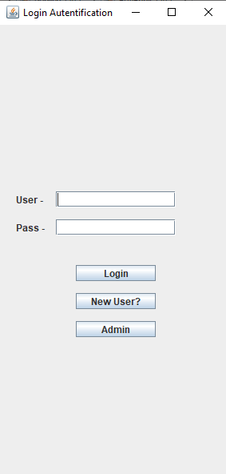

**Figure 9.3.1: Login interface**

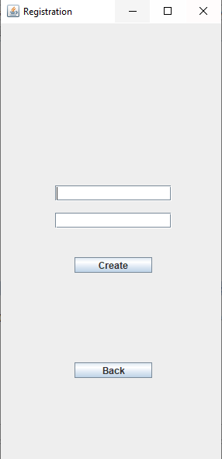

**Figure 9.3.2: Create user interface**

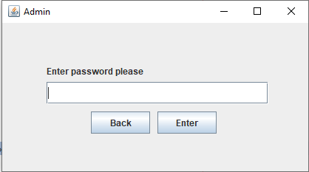

**Figure 9.3.3: Admin Login interface**

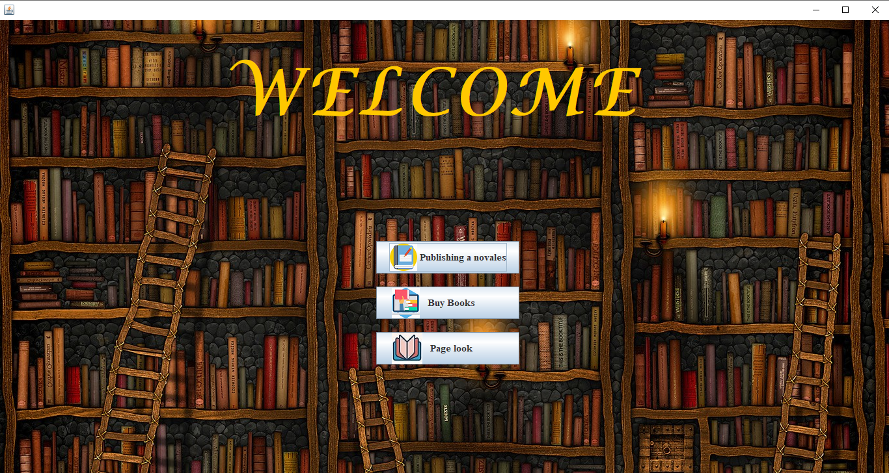

**Figure 9.3.4: Main menu interface**

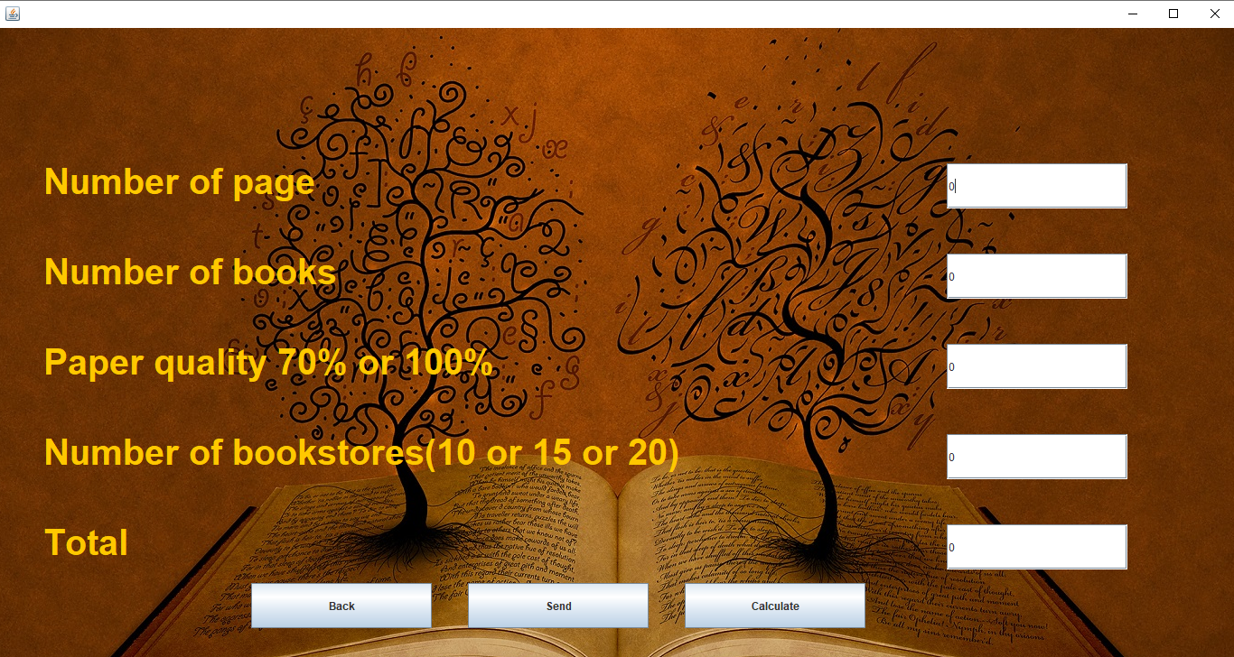

**Figure 9.3.5: publish book interface**

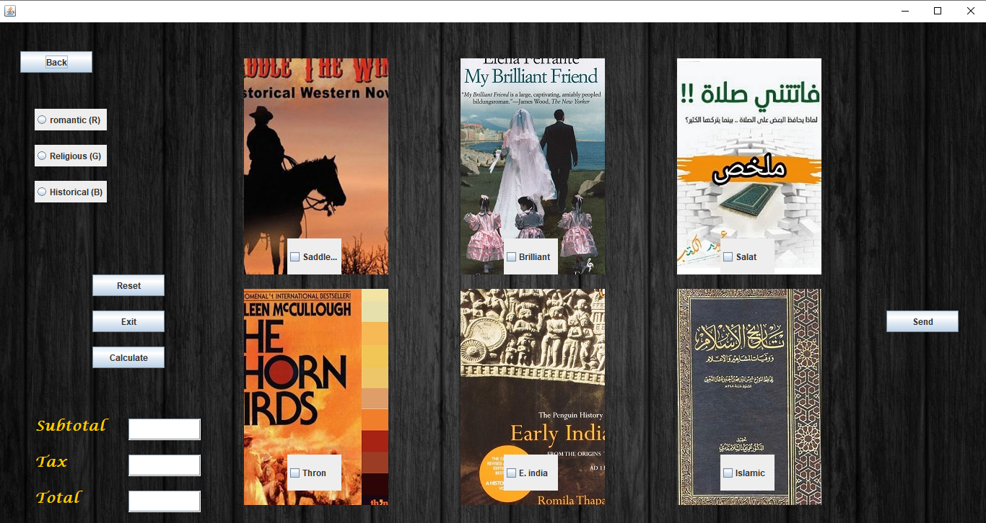

**Figure 9.3.6: Buy book interface**

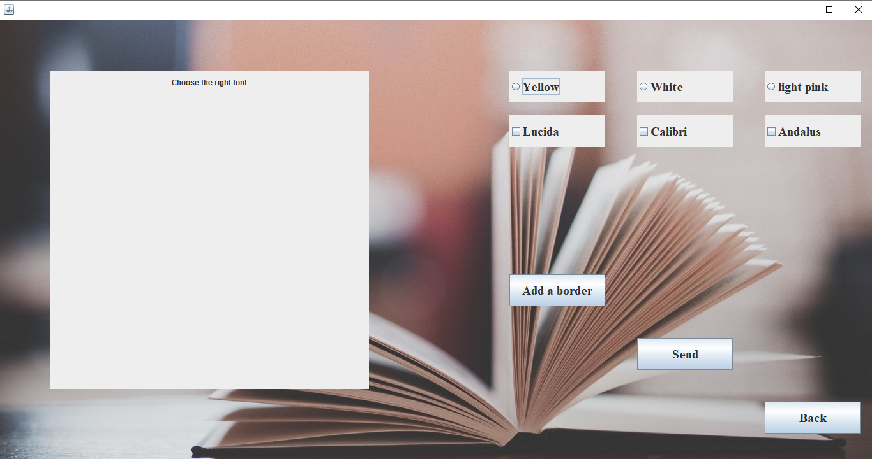

**Figure 9.3.7: Design interface**

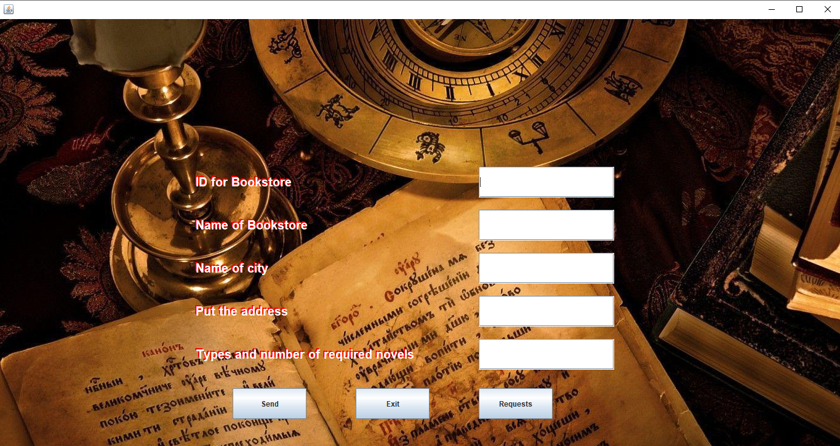

**Figure 9.3.8: Add Bookstore interface**

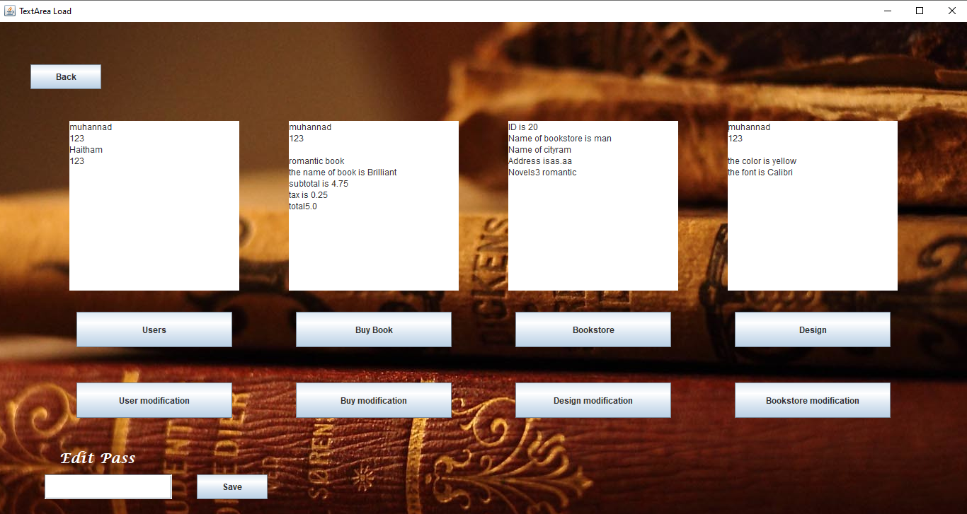

**Figure 9.3.9: display requests interface**